//@version=6
strategy("VuManChu B Long Only", overlay=false, shorttitle="VMC-LONG",
initial_capital=10000, default_qty_type=strategy.cash, default_qty_value=10000,
commission_type=strategy.commission.percent, commission_value=0.0,
slippage=1, currency=currency.USD, process_orders_on_close=true, pyramiding=2)

group_wt = "WaveTrend"
wtShow = input.bool(true, "Show WaveTrend", group=group_wt)
wtBuyShow = input.bool(true, "Show Buy dots", group=group_wt)
wtGoldShow = input.bool(true, "Show Gold dots", group=group_wt)
wtSellShow = input.bool(true, "Show Sell dots", group=group_wt)
wtDivShow = input.bool(true, "Show Div. dots", group=group_wt)
vwapShow = input.bool(true, "Show Fast WT", group=group_wt)
wtChannelLen = input.int(9, "WT Channel Length", minval=1, group=group_wt)
wtAverageLen = input.int(12, "WT Average Length", minval=1, group=group_wt)
wtMASource = input.source(hlc3, "WT MA Source", group=group_wt)
wtMALen = input.int(3, "WT MA Length", minval=1, group=group_wt)
obLevel = input.int(53, "WT Overbought Level 1", group=group_wt)
obLevel2 = input.int(60, "WT Overbought Level 2", group=group_wt)
obLevel3 = input.int(100, "WT Overbought Level 3", group=group_wt)
osLevel = input.int(-53, "WT Oversold Level 1", group=group_wt)
osLevel2 = input.int(-60, "WT Oversold Level 2", group=group_wt)
osLevel3 = input.int(-75, "WT Oversold Level 3", group=group_wt)
wtShowDiv = input.bool(true, "Show WT Regular Divergences", group=group_wt)
wtShowHiddenDiv = input.bool(false, "Show WT Hidden Divergences", group=group_wt)
showHiddenDiv_nl = input.bool(true, "Not apply OB/OS Limits on Hidden Div", group=group_wt)
wtDivOBLevel = input.int(45, "WT Bearish Divergence min", group=group_wt)
wtDivOSLevel = input.int(-65, "WT Bullish Divergence min", group=group_wt)
wtDivOBLevel_addshow = input.bool(true, "Show 2nd WT Regular Divergences", group=group_wt)
wtDivOBLevel_add = input.int(15, "WT 2nd Bearish Divergence", group=group_wt)
wtDivOSLevel_add = input.int(-40, "WT 2nd Bullish Divergence", group=group_wt)

group_mfi = "MFI"
rsiMFIShow = input.bool(true, "Show MFI", group=group_mfi)
rsiMFIperiod = input.int(60, "MFI Period", group=group_mfi)
rsiMFIMultiplier = input.float(150.0, "MFI Area multiplier", group=group_mfi)
rsiMFIPosY = input.float(2.5, "MFI Area Y Pos", group=group_mfi)

group_rsi = "RSI"
rsiShow = input.bool(true, "Show RSI", group=group_rsi)
rsiSRC = input.source(close, "RSI Source", group=group_rsi)
rsiLen = input.int(14, "RSI Length", group=group_rsi)
rsiOversold = input.int(30, "RSI Oversold", minval=0, maxval=100, group=group_rsi)
rsiOverbought = input.int(70, "RSI Overbought", minval=0, maxval=100, group=group_rsi)
rsiShowDiv = input.bool(false, "Show RSI Regular Divergences", group=group_rsi)
rsiShowHiddenDiv = input.bool(false, "Show RSI Hidden Divergences", group=group_rsi)
rsiDivOBLevel = input.int(60, "RSI Bearish Divergence min", group=group_rsi)
rsiDivOSLevel = input.int(30, "RSI Bullish Divergence min", group=group_rsi)

group_stoch = "Stoch"
stochShow = input.bool(true, "Show Stochastic RSI", group=group_stoch)
stochUseLog = input.bool(true, "Use Log?", group=group_stoch)
stochAvg = input.bool(false, "Use Average of both K & D", group=group_stoch)
stochSRC = input.source(close, "Stochastic RSI Source", group=group_stoch)
stochLen = input.int(14, "Stochastic RSI Length", group=group_stoch)
stochRsiLen = input.int(14, "RSI Length", group=group_stoch)
stochKSmooth = input.int(3, "Stochastic RSI K Smooth", group=group_stoch)
stochDSmooth = input.int(3, "Stochastic RSI D Smooth", group=group_stoch)
stochShowDiv = input.bool(false, "Show Stoch Regular Divergences", group=group_stoch)
stochShowHiddenDiv = input.bool(false, "Show Stoch Hidden Divergences", group=group_stoch)

group_tc = "Schaff"
tcLine = input.bool(false, "Show Schaff TC line", group=group_tc)
tcSRC = input.source(close, "Schaff TC Source", group=group_tc)
tclength = input.int(10, "Schaff TC", group=group_tc)
tcfastLength = input.int(23, "Schaff TC Fast Length", group=group_tc)
tcslowLength = input.int(50, "Schaff TC Slow Length", group=group_tc)
tcfactor = input.float(0.5, "Schaff TC Factor", group=group_tc)

darkMode = input.bool(false, "Dark mode", group="Mode")

colorRed = #ff0000
colorPurple = #e600e6
colorGreen = #3fff00
colorOrange = #e2a400
colorYellow = #ffe500
colorWhite = #ffffff
colorPink = #ff00f0
colorBluelight = #31c0ff
colorWT2 = #0d47a1
colorWT2_ = #131722
colormacdWT1a = #4caf58
colormacdWT1b = #af4c4c
colormacdWT1c = #7ee57e
colormacdWT1d = #ff3535
colormacdWT2a = #305630
colormacdWT2b = #310101
colormacdWT2c = #132213
colormacdWT2d = #770000

f_top_fractal(series float src) =>
src[4] < src[2] and src[3] < src[2] and src[2] > src[1] and src[2] > src[0]

f_bot_fractal(series float src) =>
src[4] > src[2] and src[3] > src[2] and src[2] < src[1] and src[2] < src[0]

f_fractalize(series float src) =>
bool isTop = f_top_fractal(src)
bool isBot = f_bot_fractal(src)
isTop ? 1 : isBot ? -1 : 0

f_findDivs(series float src, float topLimit, float botLimit, bool useLimits) =>
fractalTop = f_fractalize(src) > 0 and (useLimits ? src[2] >= topLimit : true) ? src[2] : na
fractalBot = f_fractalize(src) < 0 and (useLimits ? src[2] <= botLimit : true) ? src[2] : na
highPrev = ta.valuewhen(not na(fractalTop), src[2], 0)[2]
highPrice = ta.valuewhen(not na(fractalTop), high[2], 0)[2]
lowPrev = ta.valuewhen(not na(fractalBot), src[2], 0)[2]
lowPrice = ta.valuewhen(not na(fractalBot), low[2], 0)[2]
bearSignal = (not na(fractalTop)) and high[2] > highPrice and src[2] < highPrev
bullSignal = (not na(fractalBot)) and low[2] < lowPrice and src[2] > lowPrev
bearDivHidden = (not na(fractalTop)) and high[2] < highPrice and src[2] > highPrev
bullDivHidden = (not na(fractalBot)) and low[2] > lowPrice and src[2] < lowPrev
[fractalTop, fractalBot, lowPrev, bearSignal, bullSignal, bearDivHidden, bullDivHidden]

f_rsimfi(int _period, float _multiplier) =>
ta.sma(((close - open) / (high - low)) * _multiplier, _period) - rsiMFIPosY

f_wavetrend(series float src, int chlen, int avg, int malen) =>
esa = ta.ema(src, chlen)
de = ta.ema(math.abs(src - esa), chlen)
ci = (src - esa) / (0.015 * de)
wt1 = ta.ema(ci, avg)
wt2 = ta.sma(wt1, malen)
wtVwap = wt1 - wt2
wtOversold = wt2 <= osLevel
wtOverbought = wt2 >= obLevel
wtCross = ta.cross(wt1, wt2)
wtCrossUp = wt2 - wt1 <= 0
wtCrossDown = wt2 - wt1 >= 0
[wt1, wt2, wtVwap, wtOversold, wtOverbought, wtCross, wtCrossUp, wtCrossDown]

f_tc(series float src, int length, int fastLength, int slowLength) =>
ema1 = ta.ema(src, fastLength)
ema2 = ta.ema(src, slowLength)
macdVal = ema1 - ema2
alpha = ta.lowest(macdVal, length)
beta = ta.highest(macdVal, length) - alpha
gamma = (macdVal - alpha) / beta * 100
gamma := beta > 0 ? gamma : nz(gamma[1])
delta = gamma
delta := na(delta[1]) ? delta : delta[1] + tcfactor * (gamma - delta[1])
epsilon = ta.lowest(delta, length)
zeta = ta.highest(delta, length) - epsilon
eta = (delta - epsilon) / zeta * 100
eta := zeta > 0 ? eta : nz(eta[1])
stcReturn = eta
stcReturn := na(stcReturn[1]) ? stcReturn : stcReturn[1] + tcfactor * (eta - stcReturn[1])
stcReturn

f_stochrsi(series float _src, int _stochlen, int _rsilen, int _smoothk, int _smoothd, bool _log, bool _avg) =>
src = _log ? math.log(_src) : _src
rsiVal = ta.rsi(src, _rsilen)
kk = ta.sma(ta.stoch(rsiVal, rsiVal, rsiVal, _stochlen), _smoothk)
d1 = ta.sma(kk, _smoothd)
avg_1 = (kk + d1) / 2.0
k = _avg ? avg_1 : kk
[k, d1]

rsi = ta.rsi(rsiSRC, rsiLen)
rsiobcolor = color.new(#e13e3e, 0)
rsioscolor = color.new(#3ee145, 0)
rsinacolor = color.new(#c33ee1, 0)
rsiColor = rsi <= rsiOversold ? rsioscolor : rsi >= rsiOverbought ? rsiobcolor : rsinacolor

rsiMFI = f_rsimfi(rsiMFIperiod, rsiMFIMultiplier)
rsiMFIColorAbove = color.new(#3ee145, 0)
rsiMFIColorBelow = color.new(#ff3d2e, 0)
rsiMFIColor = rsiMFI > 0 ? rsiMFIColorAbove : rsiMFIColorBelow

[wt1, wt2, wtVwap, wtOversold, wtOverbought, wtCross, wtCrossUp, wtCrossDown] = f_wavetrend(wtMASource, wtChannelLen, wtAverageLen, wtMALen)

[stochK, stochD] = f_stochrsi(stochSRC, stochLen, stochRsiLen, stochKSmooth, stochDSmooth, stochUseLog, stochAvg)
tcVal = f_tc(tcSRC, tclength, tcfastLength, tcslowLength)

[wtFractalTop, wtFractalBot, wtLow_prev, wtBearDiv, wtBullDiv, wtBearDivHidden, wtBullDivHidden] = f_findDivs(wt2, wtDivOBLevel, wtDivOSLevel, true)
[wtFractalTop_add, wtFractalBot_add, wtLow_prev_add, wtBearDiv_add, wtBullDiv_add, wtBearDivHidden_add, wtBullDivHidden_add] = f_findDivs(wt2, wtDivOBLevel_add, wtDivOSLevel_add, true)
[wtFractalTop_nl, wtFractalBot_nl, wtLow_prev_nl, wtBearDiv_nl, wtBullDiv_nl, wtBearDivHidden_nl, wtBullDivHidden_nl] = f_findDivs(wt2, 0.0, 0.0, false)
wtBearDivHidden_ = showHiddenDiv_nl ? wtBearDivHidden_nl : wtBearDivHidden
wtBullDivHidden_ = showHiddenDiv_nl ? wtBullDivHidden_nl : wtBullDivHidden

WTBearDivColorDown = color.new(#e60000, 0)
wtBullDivColorUp = color.new(#00e676, 0)
wtBearDivColor = (wtShowDiv and wtBearDiv) or (wtShowHiddenDiv and wtBearDivHidden_) ? WTBearDivColorDown : na
wtBullDivColor = (wtShowDiv and wtBullDiv) or (wtShowHiddenDiv and wtBullDivHidden_) ? wtBullDivColorUp : na
wtBearDivColor_add = (wtShowDiv and (wtDivOBLevel_addshow and wtBearDiv_add)) or (wtShowHiddenDiv and (wtDivOBLevel_addshow and wtBearDivHidden_add)) ? WTBearDivColorDown : na
wtBullDivColor_add = (wtShowDiv and (wtDivOBLevel_addshow and wtBullDiv_add)) or (wtShowHiddenDiv and (wtDivOBLevel_addshow and wtBullDivHidden_add)) ? wtBullDivColorUp : na

[rsiFractalTop, rsiFractalBot, rsiLow_prev, rsiBearDiv, rsiBullDiv, rsiBearDivHidden, rsiBullDivHidden] = f_findDivs(rsi, rsiDivOBLevel, rsiDivOSLevel, true)
[rsiFractalTop_nl, rsiFractalBot_nl, rsiLow_prev_nl, rsiBearDiv_nl, rsiBullDiv_nl, rsiBearDivHidden_nl, rsiBullDivHidden_nl] = f_findDivs(rsi, 0.0, 0.0, false)
rsiBearDivHidden_ = showHiddenDiv_nl ? rsiBearDivHidden_nl : rsiBearDivHidden
rsiBullDivHidden_ = showHiddenDiv_nl ? rsiBullDivHidden_nl : rsiBullDivHidden
rsiBearColor = color.new(#e60000, 0)
rsiBullColor = color.new(#38ff42, 0)
rsiBearDivColor = (rsiShowDiv and rsiBearDiv) or (rsiShowHiddenDiv and rsiBearDivHidden_) ? rsiBearColor : na
rsiBullDivColor = (rsiShowDiv and rsiBullDiv) or (rsiShowHiddenDiv and rsiBullDivHidden_) ? rsiBullColor : na

[stochFractalTop, stochFractalBot, stochLow_prev, stochBearDiv, stochBullDiv, stochBearDivHidden, stochBullDivHidden] = f_findDivs(stochK, 0.0, 0.0, false)
stochbearcolor = color.new(#e60000, 0)
stochbullcolor = color.new(#38ff42, 0)
stochBearDivColor = (stochShowDiv and stochBearDiv) or (stochShowHiddenDiv and stochBearDivHidden) ? stochbearcolor : na
stochBullDivColor = (stochShowDiv and stochBullDiv) or (stochShowHiddenDiv and stochBullDivHidden) ? stochbullcolor : na

signalcolorup = color.new(#00e676, 0)
signalcolordown = color.new(#ff5252, 0)
signalColor = wt2 - wt1 > 0 ? signalcolordown : signalcolorup

buySignal = wtCross and wtCrossUp and wtOversold
buySignalDiv = (wtShowDiv and wtBullDiv) or (wtShowDiv and wtBullDiv_add) or (stochShowDiv and stochBullDiv) or (rsiShowDiv and rsiBullDiv)
buySignalDiv_color = wtBullDiv ? colorGreen : wtBullDiv_add ? color.new(colorGreen, 60) : rsiShowDiv ? colorGreen : na

sellSignal = wtCross and wtCrossDown and wtOverbought
sellSignalDiv = (wtShowDiv and wtBearDiv) or (wtShowDiv and wtBearDiv_add) or (stochShowDiv and stochBearDiv) or (rsiShowDiv and rsiBearDiv)
sellSignalDiv_color = wtBearDiv ? colorRed : wtBearDiv_add ? color.new(colorRed, 60) : rsiBearDiv ? colorRed : na

lastRsi = ta.valuewhen(not na(wtFractalBot), rsi[2], 0)[2]
wtGoldBuy = ((wtShowDiv and wtBullDiv) or (rsiShowDiv and rsiBullDiv)) and wtLow_prev <= osLevel3 and wt2 > osLevel3 and wtLow_prev - wt2 <= -5 and lastRsi < 30

green_dot = buySignal
red_dot = sellSignal

group_strat = "Estrategia"
exitMode = input.string("Percent", "Salida TP/SL", options=["Percent", "Time", "RedDot"], group=group_strat)
sl_pct = input.float(1.0, "SL % (modo %)", minval=0.1, maxval=20.0, step=0.1, group=group_strat) * 0.01
tp_pct = input.float(2.0, "TP % (modo %)", minval=0.1, maxval=50.0, step=0.1, group=group_strat) * 0.01
maxBarsHold = input.int(20, "Barras máx. (modo tiempo)", minval=1, maxval=500, group=group_strat)
risk_pct = input.float(1.0, "Riesgo % por trade", minval=0.1, maxval=100.0, step=0.1, group=group_strat) * 0.01
lev = input.int(1, "Apalancamiento (1-100)", minval=1, maxval=100, group=group_strat)

risk_cash = strategy.equity * risk_pct
sl_dist_price = close * sl_pct
qty_pct = sl_dist_price > 0 ? risk_cash / sl_dist_price * lev : 0.0
qty_time = close > 0 ? risk_cash / close * lev : 0.0
entry_qty = exitMode == "Percent" ? qty_pct : qty_time

var int entryBarIdx = na
if strategy.position_size == 0
entryBarIdx := na
else if strategy.position_size[1] == 0 and strategy.position_size > 0
entryBarIdx := bar_index

barsInTrade = not na(entryBarIdx) ? bar_index - entryBarIdx : 0

long_entry = green_dot and strategy.opentrades < 2

if long_entry
strategy.entry("Long", strategy.long, qty=entry_qty)

if exitMode == "Percent" and strategy.position_size > 0
avg = strategy.position_avg_price
strategy.exit("X", "Long", stop=avg * (1 - sl_pct), limit=avg * (1 + tp_pct))

if exitMode == "Time" and strategy.position_size > 0 and barsInTrade >= maxBarsHold
strategy.close("Long", comment="Time")

if exitMode == "RedDot" and red_dot and strategy.position_size > 0
strategy.close("Long", comment="Red")

bgcolor(darkMode ? color.new(#000000, 0) : na)
zLine = plot(0, color=color.new(colorWhite, 50), display=display.all)
rsiMfiBarTopLine = plot(rsiMFIShow ? -95 : na, title="MFI Bar TOP", display=display.all)
rsiMfiBarBottomLine = plot(rsiMFIShow ? -99 : na, title="MFI Bar BOTTOM", display=display.all)
fill(rsiMfiBarTopLine, rsiMfiBarBottomLine, color=rsiMFIColor)

colorWT1blue = color.new(#4994ec, 0)
colorWT2purple = color.new(#1f1559, 0)
plot(wtShow ? wt1 : na, style=plot.style_area, title="WT Wave 1", color=color.new(colorWT1blue, 30), display=display.all)
plot(wtShow ? wt2 : na, style=plot.style_area, title="WT Wave 2", color=color.new(colorWT2purple, 25), display=display.all)

VWAPColor = color.new(#ffffff, 50)
plot(vwapShow ? wtVwap : na, title="VWAP", color=VWAPColor, style=plot.style_area, linewidth=2, display=display.all)

plot(rsiMFIShow ? rsiMFI : na, style=plot.style_area, title="rsiMFI", color=color.new(rsiMFIColor, 50), display=display.all)

plot(series=not na(wtFractalTop) ? wt2[2] : na, title="WT Bearish Divergence", color=wtBearDivColor, linewidth=2, offset=-2, display=display.all)
plot(series=not na(wtFractalBot) ? wt2[2] : na, title="WT Bullish Divergence", color=wtBullDivColor, linewidth=2, offset=-2, display=display.all)
plot(series=not na(wtFractalTop_add) ? wt2[2] : na, title="WT 2nd Bearish Divergence", color=wtBearDivColor_add, linewidth=2, offset=-2, display=display.all)
plot(series=not na(wtFractalBot_add) ? wt2[2] : na, title="WT 2nd Bullish Divergence", color=wtBullDivColor_add, linewidth=2, offset=-2, display=display.all)

plot(rsiShow ? rsi : na, title="RSI", color=rsiColor, linewidth=2, display=display.all)
plot(series=not na(rsiFractalTop) ? rsi[2] : na, title="RSI Bearish Divergence", color=rsiBearDivColor, linewidth=1, offset=-2, display=display.all)
plot(series=not na(rsiFractalBot) ? rsi[2] : na, title="RSI Bullish Divergence", color=rsiBullDivColor, linewidth=1, offset=-2, display=display.all)

stochkcolor = color.new(#21baf3, 70)
stochdcolor = color.new(#673ab7, 90)
stochKplot = plot(stochShow ? stochK : na, title="Stoch K", color=stochkcolor, linewidth=2, display=display.all)
stochDplot = plot(stochShow ? stochD : na, title="Stoch D", color=stochdcolor, linewidth=1, display=display.all)
stochFillColor = stochK >= stochD ? color.new(#21baf3, 95) : color.new(#673ab7, 90)
fill(stochKplot, stochDplot, color=stochFillColor)

plot(series=not na(stochFractalTop) ? stochK[2] : na, title="Stoch Bearish Divergence", color=stochBearDivColor, linewidth=1, offset=-2, display=display.all)
plot(series=not na(stochFractalBot) ? stochK[2] : na, title="Stoch Bullish Divergence", color=stochBullDivColor, linewidth=1, offset=-2, display=display.all)

plot(tcLine ? tcVal : na, color=color.new(#673ab7, 25), linewidth=2, title="Schaff TC 1", display=display.all)
plot(tcLine ? tcVal : na, color=color.new(colorWhite, 50), linewidth=1, title="Schaff TC 2", display=display.all)

plot(obLevel2, title="OB LVL 2", color=color.new(colorWhite, 0), linewidth=1, style=plot.style_stepline, display=display.all)
plot(obLevel3, title="OB LVL 3", color=color.new(colorWhite, 0), linewidth=1, style=plot.style_circles, display=display.all)
plot(osLevel2, title="OS LVL 2", color=color.new(colorWhite, 0), linewidth=1, style=plot.style_stepline, display=display.all)

plot(wtCross ? wt2 : na, title="Buy and sell circle", color=signalColor, style=plot.style_circles, linewidth=3, display=display.all)
plotchar(wtBuyShow and buySignal ? -107 : na, title="Buy circle", char="·", color=colorGreen, location=location.absolute, size=size.small)
plotchar(wtSellShow and sellSignal ? 105 : na, title="Sell circle", char="·", color=colorRed, location=location.absolute, size=size.small)
plotchar(wtDivShow and buySignalDiv ? -106 : na, title="Divergence buy circle", char="•", color=buySignalDiv_color, location=location.absolute, size=size.small, offset=-2)
plotchar(wtDivShow and sellSignalDiv ? 106 : na, title="Divergence sell circle", char="•", color=sellSignalDiv_color, location=location.absolute, size=size.small, offset=-2)
plotchar(wtGoldBuy and wtGoldShow ? -106 : na, title="Gold buy circle", char="•", color=colorOrange, location=location.absolute, size=size.normal, offset=-2)

alertcondition(buySignal, title="GREEN", message="Green")
alertcondition(sellSignal, title="RED", message="Red")
alertcondition(wtGoldBuy, title="GOLD", message="Gold")

DE ESTA ESTRATEGIA BASE UTILIZARAS DIFERENTES TEMPORALIDADES. QUIERO QUE CADA ESTRATEGIA SE EJECUTE DE MANERA INDEPENDIENTE. REDUCE ENTRE 4 EL RIESGO POR TRADE (DE 1% A .166%)

Temporalidad 1H, 2H, 3H, 4H
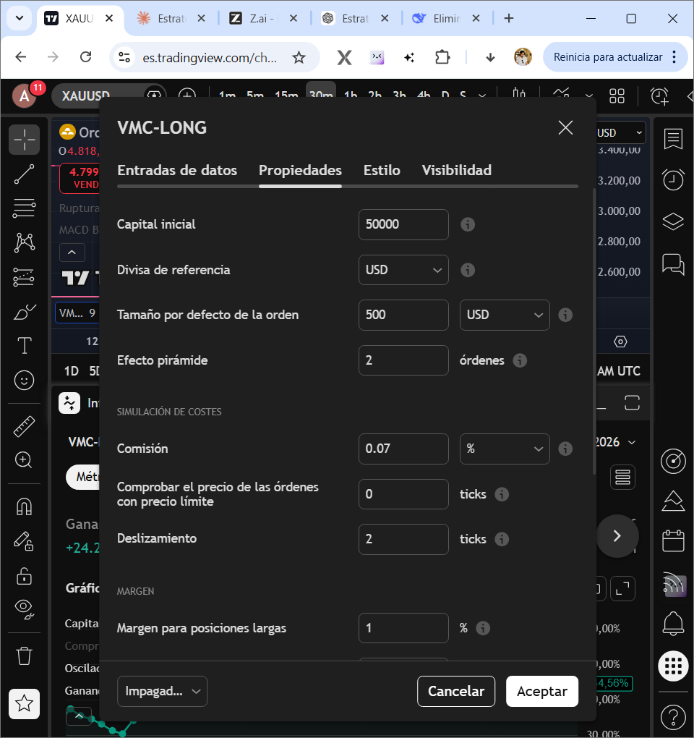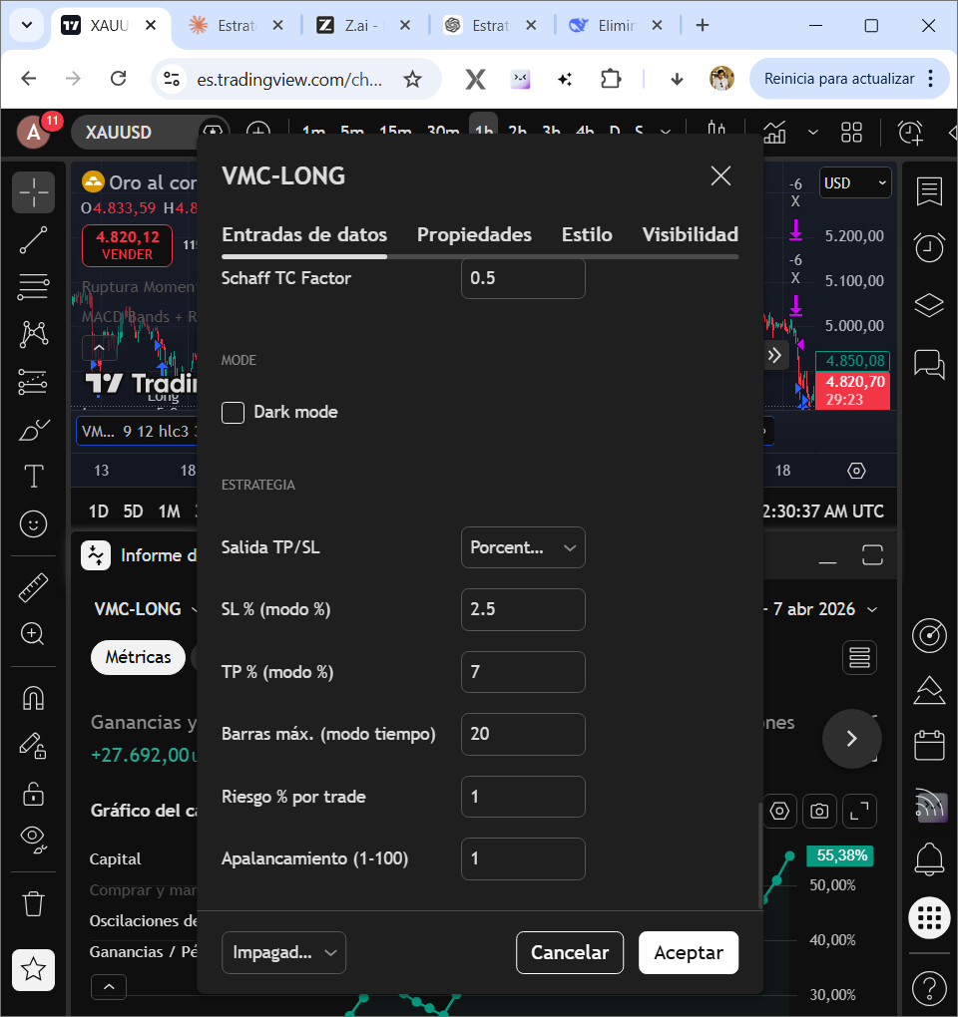

TEMPORALIDAD 2H:

